ResQLink

Enhancing Community Preparedness and Response to Disasters

Contents
- Solution Details
- Implementation Plan
- Visual Aids
- Team Structure
- References

Solution Details:

Team Introduction

Team Name: NowSquad
Team Members: Vansh Agrawal, Bandi Gayathri, Munagapati Bhavana, Vivek Kumar Pradhan, Rudraksha Ravinder, Kaditham Gowtham.
College: GITAM University

Chosen Problem Statement: Enhancing Community Preparedness and Response to Disasters.

Organize Content Into Key Categories

- Chosen Problem:

Problem 16 – Enhancing Community Preparedness and Response to Disasters

During disasters like floods, cyclones, or earthquakes, coordination between citizens, volunteers, and authorities is often fragmented. This leads to delayed aid delivery, duplication or neglect of critical tasks, and inefficient use of resources. In urgent situations, even a few minutes’ delay can cost lives and worsen damage.

For example, during the 2018 Kerala floods, thousands of rescue requests were scattered across social media, calls, and local groups, making it difficult for authorities to track, verify, and respond efficiently. Without a unified platform, valuable time was lost in manually consolidating information and assigning rescue teams.

Our goal is to build a single connected system where citizens can request help instantly, officials can verify and approve alerts, volunteers can receive the right tasks based on skills and location, and authorities can track every action in real time—all within one platform.

- Proposed Solution:

Our solution systematically addresses the challenge of fragmented disaster response and inefficient civic management by implementing a unified, automated platform on ServiceNow. The platform is designed to enable seamless real-time information sharing, rapid task assignment, effective resource coordination, and transparent progress tracking—ensuring both proactive disaster preparedness and responsive action after emergencies.

Structure and Flow
Part 1: Early Warning & Coordinated Disaster Response
- Data Ingestion & Prediction:
The platform continuously pulls real-time weather and seismic data from official APIs (IMD, NOAA, USGS) using ServiceNow IntegrationHub. These feeds are processed by a built-in or external NLP/ML engine that predicts disaster risks and returns a risk score and impact estimate.
- Alert Creation & Approval:
If a predicted risk exceeds the threshold, an automated alert is created and enters a “Proposed_Alerts” workflow. Government admins review these in a dedicated portal, approving or rejecting potential alerts with a single action.
- Broadcasting & Notification:
Approved alerts trigger automated mass notifications via SMS, email, and Now Mobile push—tailored by user role (citizens, volunteers, authorities). The Service Portal displays real-time alert banners for all active emergencies.
- Action & Response Coordination:
Once a disaster is active, citizens can submit detailed help requests. The platform’s workflow engine auto-assigns each ticket to suitable volunteers or government teams based on geo-location and skill, providing real-time status tracking and central oversight of all aid and resource distribution.

Part 2: Streamlining Everyday Civic Issues

- Citizen Ticketing & Departmental Routing:
Citizens report local issues (e.g., power cut, waste, road problems) using user-friendly web/mobile forms. The system auto-routes tickets to the responsible department via ServiceNow scripts and business rules, starting SLA timers for timely resolution.
- Transparency & Access Control:
Role-based access ensures citizens track only their own submissions, departments see only their assignments, and admins have full oversight. ServiceNow dashboards provide all stakeholders with real-time KPIs, SLA tracking, and performance heatmaps.
- Government Oversight:
Higher officials monitor departmental and system-wide performance, intervening and escalating as needed to ensure fast, reliable service for all citizens.

Technology Stack
- Core Platform: ServiceNow (including Service Portal, Flow Designer, Performance Analytics)
- Integration: ServiceNow IntegrationHub (for IMD, NOAA, USGS APIs and third-party notifications like Twilio)
- Automation: Assignment Rule scripts, business rules, and workflows for full end-to-end automation
- Mobile Access: Now Mobile app for cross-platform and offline capabilities
- Analytics & Reporting: ServiceNow Performance Analytics and custom dashboards for actionable insights
In summary, this two-part ServiceNow solution enables proactive disaster prevention and rapid emergency response, while optimizing day-to-day civic service management—eliminating delays, reducing manual errors, and providing real-time, actionable transparency across all levels of community and government interaction.
Innovation

- Innovation:

- End-to-End Automation:
Unlike traditional approaches that rely on manual data handling, delayed SMS blasts, or static dashboards, this platform uses NLP-driven risk assessment and ServiceNow automation scripts to seamlessly process real-time data, generate alerts, assign tasks, and track completion—all with minimal human intervention.
- Unified Platform for All Scenarios:
Most existing systems address either disaster response or routine civic issues separately, often requiring multiple apps and manual coordination. In contrast, your solution brings both disaster alerts and everyday civic management together within a single, integrated ServiceNow instance, ensuring consistency, efficiency, and a unified user experience.
- Predictive and Proactive Capabilities:
The use of live feeds from trusted agencies (IMD, NOAA, USGS) combined with a predictive NLP/ML engine enables early warnings and readiness—moving beyond basic reactive systems that only respond after emergencies occur.
- Mobile-First, Always-On Engagement:
By leveraging Now Mobile’s store-and-forward functionality, field volunteers and users can interact with the system even when offline—a capability rarely offered by conventional web-only civic or emergency platforms.

Comparison with Current Practices:

- Traditional emergency management systems rely heavily on manual communication and fragmented data, causing delays, repeated efforts, and missed needs.
- Standalone civic complaint portals rarely support task automation, real-time notifications, or predictive alerting.
- Few existing solutions provide cross-platform mobile access with resilient offline support and end-to-end traceability from prediction through task resolution.

Competitive Edge:

Our platform’s combination of predictive analytics, full automation, role-based response, integrated mobile tech, and advanced reporting gives communities, volunteers, and governments a faster, more transparent, and more coordinated disaster and civic issue response than ever before. This holistic approach, enabled by ServiceNow’s ecosystem, distinctly outperforms conventional, fragmented solutions on speed, reliability, and user empowerment.

Implementation Plan

- Timeline:

Phase 1: Planning & Requirements Finalization
Duration: 15th Aug – 18th Aug (4 days)
- Confirm and finalize detailed requirements
- Define user roles, workflows, and acceptance criteria
- Outline data models, tech stack, and integration points
- Prepare initial project plan & milestones

Phase 2: Solution Design
Duration: 19th Aug – 22nd Aug (4 days)
- Design architecture and ServiceNow module configurations
- Create ERDs, data schemas, and workflow diagrams
- Design Service Portal wireframes and mobile app screen flows
- Define SLA rules, business rules, and notification templates

Phase 3: Development
Duration: 23rd Aug – 31st Aug (9 days)
- Setup ServiceNow instance, configure modules (ITSM, CSM, FSM, Performance Analytics)
- Develop IntegrationHub connectors for weather/seismic APIs
- Implement NLP/ML prediction integration
- Build alert workflows, admin approval portal, and notification engine
- Create forms, auto-assignment scripts for tickets and volunteer tasks
- Develop dashboards and Now Mobile customization for mobile access

Phase 4: Testing (Functional & Integration)
Duration: 1st Sept – 5th Sept (5 days)
- Perform Automated Test Framework (ATF) and manual functional testing
- Conduct integration testing for APIs, notifications, and mobile sync
- Validate workflows from prediction to task completion
- Perform role-based access and security testing
- Fix bugs and refine features based on test results

Phase 5: Buffer & Backlog Completion
Duration: 6th Sept – 10th Sept (5 days)
- Address remaining backlog items and enhancements
- Conduct User Acceptance Testing (UAT) with stakeholders
- Finalize documentation and deployment preparations
- Performance tuning and final validations

Summary Table

Phase | Dates | Key Activities
Planning | 15 Aug to 18 Aug | Requirements, scope, project plan
Design | 19 Aug to 22 Aug | Architecture, UI/UX wireframes, workflows
Development | 23 Aug to 31 Aug | Coding integrations, workflows, portals, mobile
Testing | 1 Sept to 5 Sept | Functional, integration, security tests
Buffer/Backlogged Work | 6 Sept to 10 Sept | Bug fixes, UAT, documentation, deployment prep

- Tools and Technologies:
ServiceNow Modules Utilized
- IT Service Management (ITSM):
  - Core ticketing for disaster requests and civic issues (Incident, Problem, Request Management).
  - Workflow automation and service catalog for structured submissions and routing.
- Customer Service Management (CSM):
  - Manages citizen interactions, cases, and communication workflows.
  - Enables omni-channel engagement (portal, mobile, email).
- Field Service Management (FSM):
  - Assigns and tracks tasks for field volunteers and department workers.
  - Supports location-based task allocation and on-the-go updates.
- Performance Analytics:
  - Provides advanced dashboards and reporting for KPIs, SLAs, volunteer engagement, and heatmaps.
- IntegrationHub:
  - Orchestrates real-time data ingestion from external APIs (IMD, NOAA, USGS).
  - Connects with third-party notification services (e.g., Twilio for SMS, email gateways).
- Service Portal:
  - Delivers unified, role-based web interfaces for citizens, admins, volunteers, and officials.
- Now Mobile:
  - Enables mobile access for real-time ticketing, notifications, and offline reporting by field users and citizens.
- ReactJS:
  - The website will be developed using React to deliver a responsive and user-friendly interface, and will seamlessly connect to ServiceNow through APIs for real-time data retrieval, submission, and workflow interaction.

Add-ons and Integrations
- Third-party API Integrations:
  - IMD, NOAA, USGS APIs: For live weather and seismic data feeds.
  - NLP/ML Engine: Integrated via REST/SOAP API for real-time disaster risk prediction.
- Notification Services:
  - Twilio: For SMS alerts and push notifications.
  - Email Gateways (SendGrid, SMTP): For large-scale, reliable alert delivery.
- Geo-mapping & Location Services:
  - Integration with mapping APIs (e.g., Google Maps or Mapbox) to capture and display locations of incidents and volunteers.
- Document & Image Storage:
  - Integration with cloud storage (e.g., AWS S3, ServiceNow Attachments) for photo uploads in incident/civic tickets.
- Authentication & Identity Management:
  - SSO integration (e.g., SAML, OAuth) for secure, role-based platform access across stakeholders.

Testing and Monitoring
- Automated Testing:
  - ATF (Automated Test Framework) for ServiceNow: To automate functional, regression, and integration testing of custom workflows, forms, and portals.
- Performance Monitoring:
  - ServiceNow Performance Analytics: Real-time dashboards for tracking SLAs, system KPIs, and identifying bottlenecks.
  - ServiceNow Instance Performance Dashboard: Monitors API throughput, page load times, and user session health.
- External Monitoring & Logging:
  - Integration with Application Performance Monitoring (APM) tools (e.g., New Relic, Dynatrace) for advanced monitoring and alerting on uptime, latency, and system errors.
  - Log Management Add-ons (e.g., Splunk, ServiceNow Event Management) to aggregate and alert on key events and failures.
- UAT (User Acceptance Testing):
  - Dedicated UAT environment for scenario-based manual testing by stakeholder representatives before each major deployment.
- Feedback Collection:
  - In-app feedback modules and ServiceNow Survey Management for continuous user feedback and rapid improvement.

Visual aids

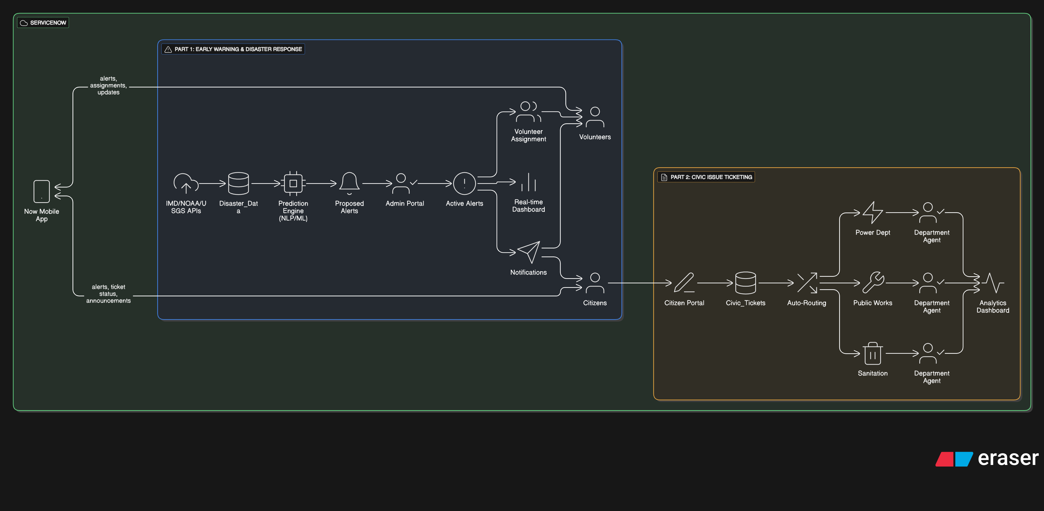

The Team



Vansh Agrawal  Team Lead  Team Lead | Bandi Gayathri  ServiceNow Developer  Team  Lead | Munagapati Bhavana  ServiceNow Developer  Team  Lead



Kaditham Gowtham  UI/UX Designer  Team Lead | Rudraksha Ravinder  DocumentationTeam  Lead | Vivek Kumar Pradhan  Tester  Team  Lead

References

ServiceNow Guides: Guides | ServiceNow Developers
ServiceNow Documentation: https://docs.servicenow.com
React Documentation:https://react.dev

